DS-A6 | Causal Claim and Sensitivity Analysis
Access Git-Hub: https://github.com/alldeolove10-SJ/2026A8000531008_DEONISIO-YOHANES-WILFRIDUS-HORNAY_DS_A6_Causal-Claim-and-Sensitivity-Analysis
Purpose: Demonstrate the mechanics of defining a causal estimand, using a DAG to reason about adjustment, checking an unobserved-confounding threat, and writing a bounded conclusion.
Original data source website: https://users.nber.org/~rdehejia/data/.nswdata2.html and https://rctvsobs.org/dataset/female-lalonde
Data provenance. 2400 synthetic rows generated with seed 6042. SHA-256: 5121872846dfeeb667659dbbab9d20f5a9416dbc5adaa0adb46196cc7b961729. The data generator intentionally includes a true +3-point tutoring effect, measured confounders, an unobserved motivation factor, a post-treatment mediator, and a pre-treatment negative-control outcome.

Example causal structure
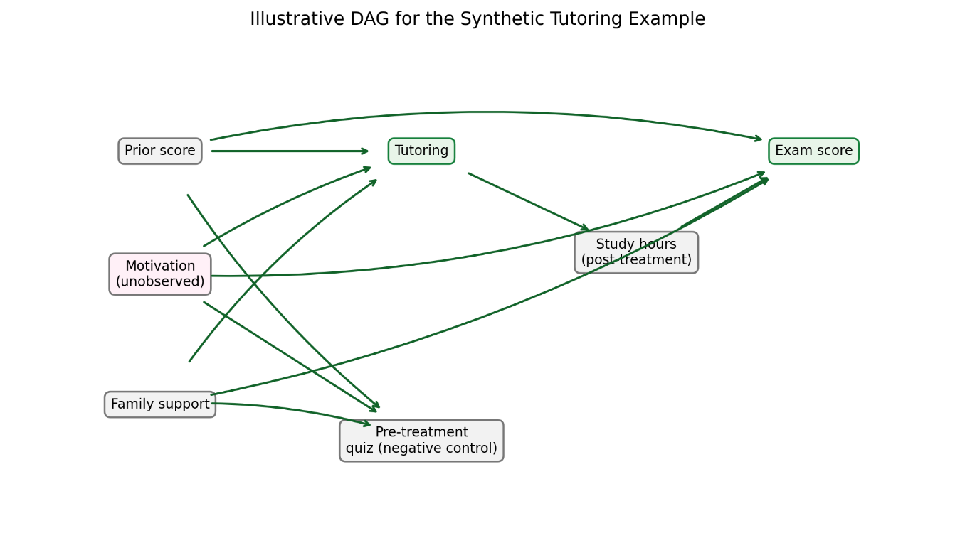
Figure 1. Illustrative DAG. Prior score and family support are measured common causes; motivation is unobserved and affects treatment and outcome; study hours is post-treatment mediator; selection can become a collider if conditioned on.

Identification warning
Adjustment for observed pre-treatment covariates does not by itself establish exchangeability when motivation remains unobserved. The example is useful because the data-generating mechanism is known to the author; in real observational data, that mechanism is not known. If assumptions are not defensible, downgrade the conclusion to association.

Estimates and counterexamples
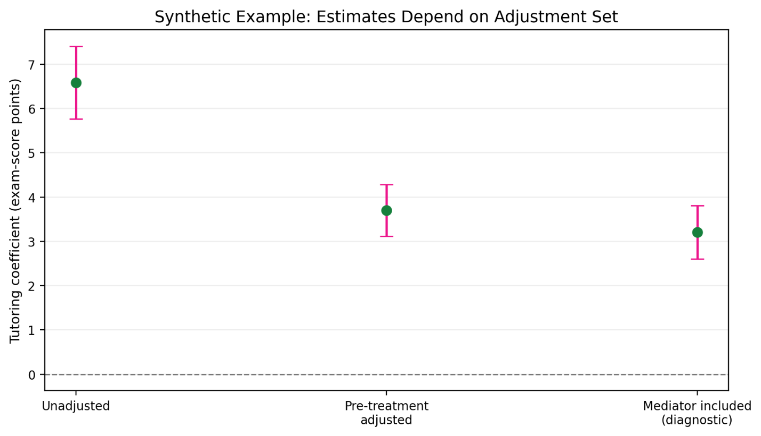
Figure 2. Estimated treatment coefficient under different adjustment sets. Including post-treatment study hours changes the estimand and can block part of the total effect; this fit is a diagnostic comparison, not the preferred total-effect estimate.
Analysis | Estimate | 95% CI
Unadjusted association | 6.59 | [5.77, 7.40]
Adjusted for pre-treatment covariates | 3.70 | [3.11, 4.29]
Including post-treatment mediator (diagnostic only) | 3.20 | [2.60, 3.80]
Negative-control outcome: pre-treatment quiz | 1.41 | [0.87, 1.95]
The pre-treatment negative-control outcome should not be caused by future tutoring. A nonzero adjusted association is a warning signal for residual confounding, measurement problems, or model misspecification; it is not a mechanical proof of exactly how much bias remains.

Sensitivity analysis
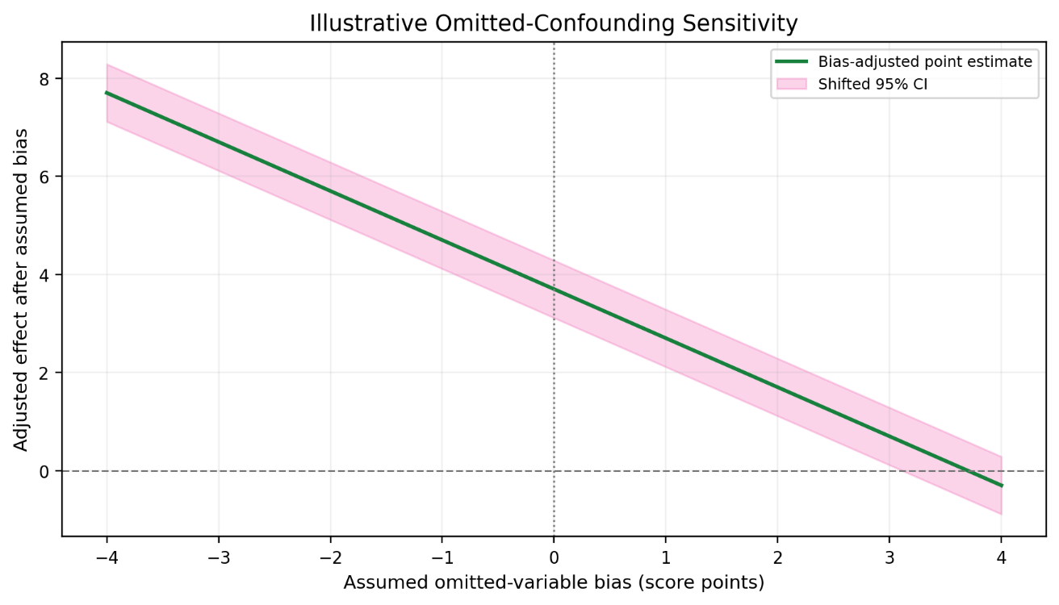
Figure 3. Illustrative bias-shift curve. The x-axis is an assumed omitted-variable bias in score-point units; the adjusted estimate and interval are shifted by that assumed amount. This transparent teaching device is not a universal sensitivity estimator and its bias range must be justified in a real study.
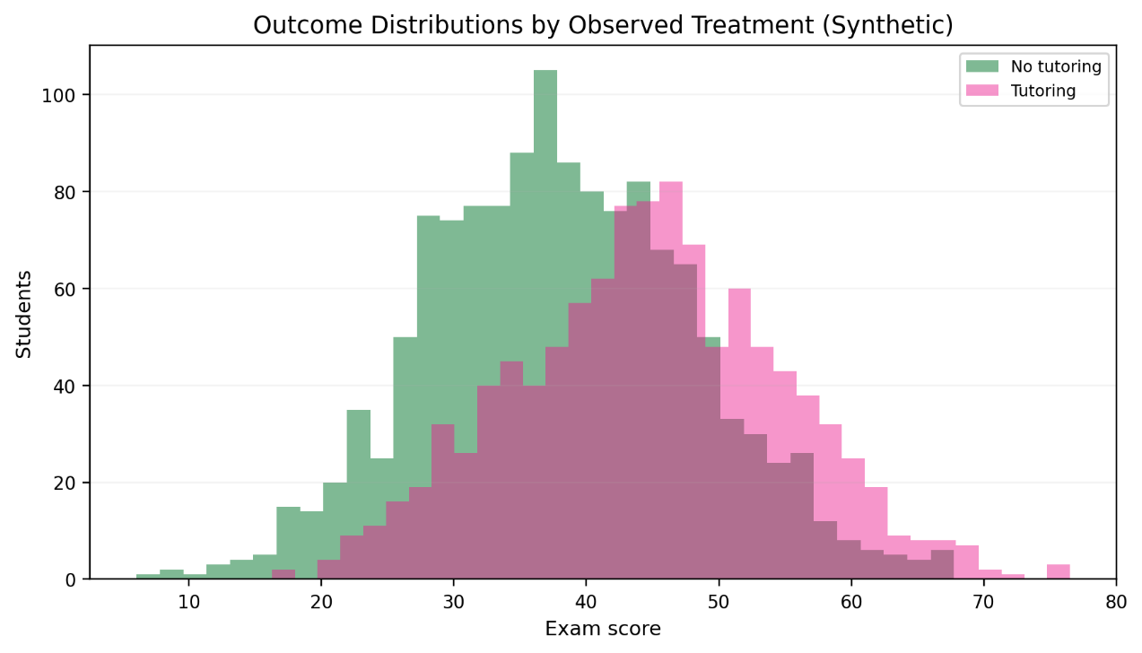
Figure 4. Observed outcome distributions by treatment group. Difference in distributions alone is not a causal estimate because treatment assignment is not randomized in this synthetic setup.

Apply the method to my own DS-A6
  - DAG and assumptions table: show confounders, mediators, colliders, and unobserved variables; justify adjustment and identification assumptions.
  - Analysis code/results: execute one estimate and record uncertainty.
  - Sensitivity/refutation evidence: implement sensitivity, negative control, or refutation and include a plausible counterexample.

Reproduction
From the project root run `python-m requirements.txt`, then `python src/demo_causal_sensitivity.py`. Keep the raw CSV results and generated figures.

Claim boundary
An adjusted observational association is not automatically causal. Causal interpretation depends on intervention definition, temporal order, consistency, positivity, exchangeability, measurement, selection, and no-interference assumptions.

